Documentation of Business Flick

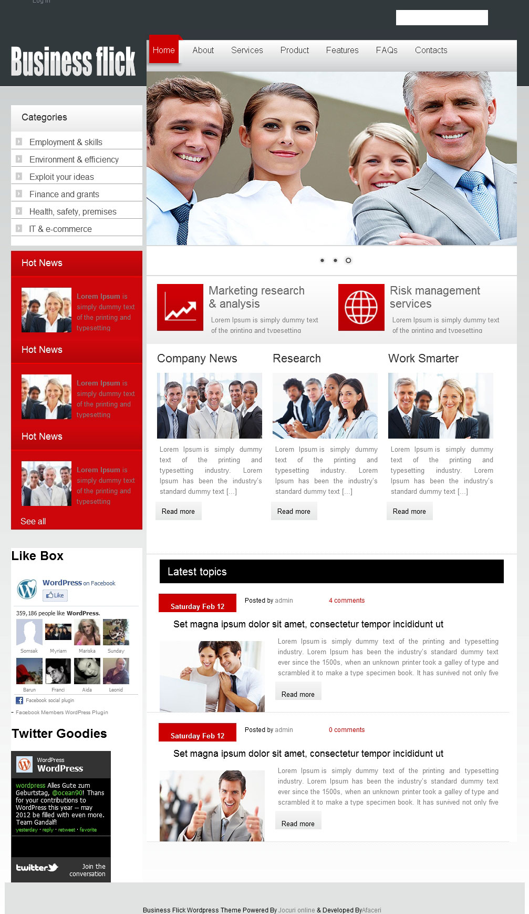
Figure 1
Business Flick is a free Word Press theme with featured posts option. Suitable for any version. Theme Options at admin panel:
FEATURES
- Easy to use options page
- Featured Image Ready
- easy editable from admin options
- Compatible with latest Word Press versions
- Widgets Ready
- SEO Optimized
- Fixed width
- Tested and compatible with all major browsers: IE, FF, Safari, chrome.

A) Initially we must know about how the post will be appearing on index page of website through word press.
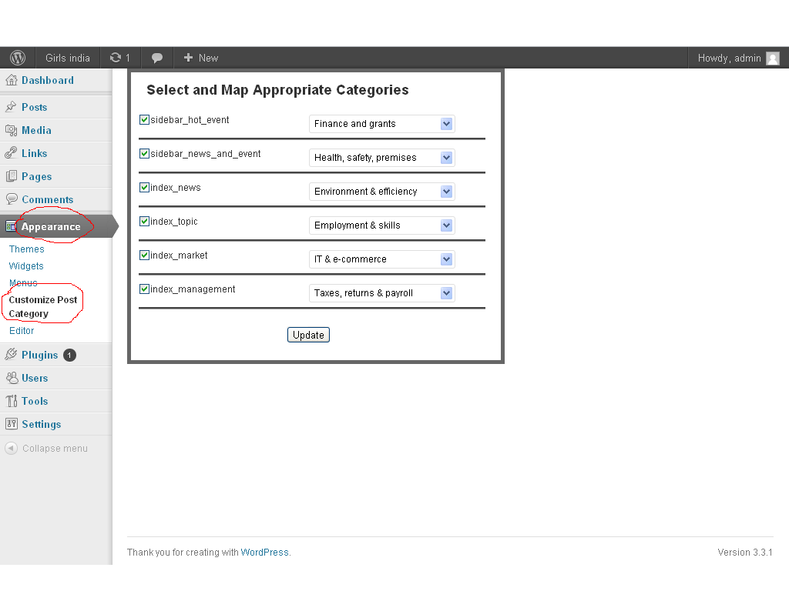
Figure 2

Through the above image we’ll understand how to add post which will be showing at the index page of website. Initially go the wp-admin of your wp-site then login from that, Hence a Dashboard will be appear.
Make sure they all are checked.
Let us understand in some points:
- Go to the Appearance of your dashboard which is notified through the red circle In figure
- Then after that go to the Customize post category all post which has came here through code. After this a new dialogue box will be appear in front of you as shown in figure1.
Here we will look one-by-one options which have shown above in the figure.

Here we’ll show about the how looks the front page after updating the page which was shown above in custom post categories page, which were shown in the appearance of the Dashboard.
Hot News


Figure 4

Latest topics
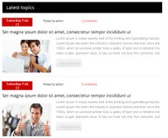

Figure 5

Marketing


Figure 6

Management
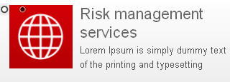
Figure 7
News
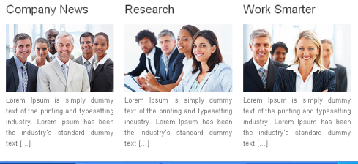
The drop-down which shows above is the list of categories in your theme.
Figure 8

It’s all about the post look like this through the word press on website.
Now move on to the Slider banner. How it will be worked through the word press let us know that.
2) Initially go to the in appearance then go to the header of the wp-admin then a new window will be open,then go for the upload image and size of the image is fix according to the banner I.E. 705X330,after that a option will come the name is Crop image ,after selecting this you’ll get your ideal size image in which you want to have shown in the preview section, After uploading the two images here in the bottom section an option will come I.e. Random and Slider in this you’ll go to the slider and change the slider setting , width and height as a image width and height which were fix at the uploading time and many more. After saving all of your setting you’ll get back on this screen which is shown below.
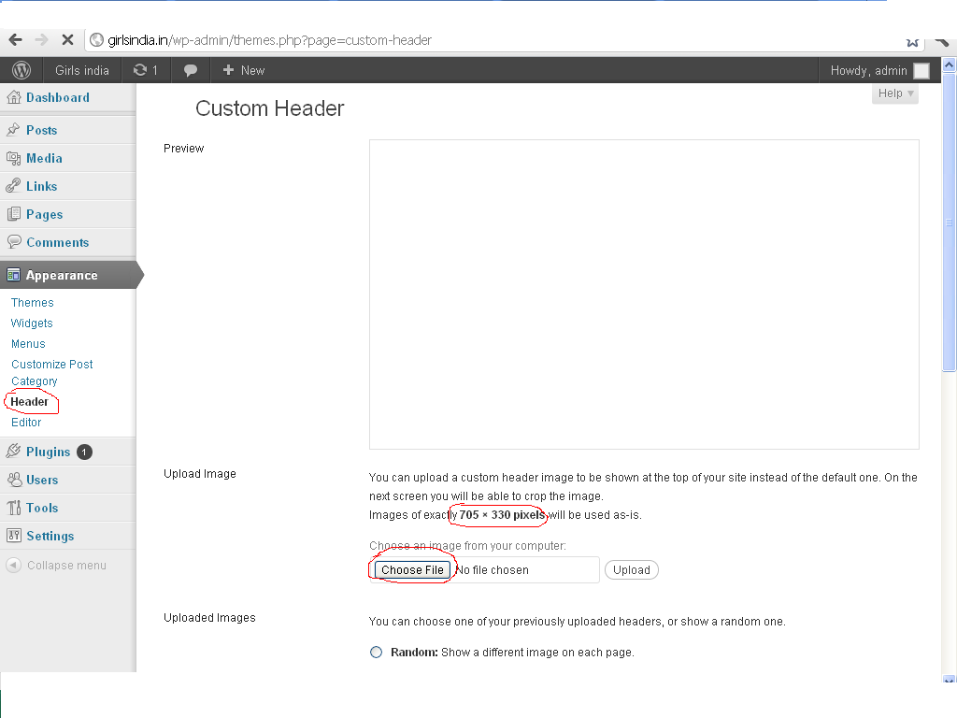
Figure 9

Footer part of screen shots.
Hence a button will be shown in front of you name as Remove header image. After clicking on it the image will be remove which is shown in preview section.
After then come to the save button.
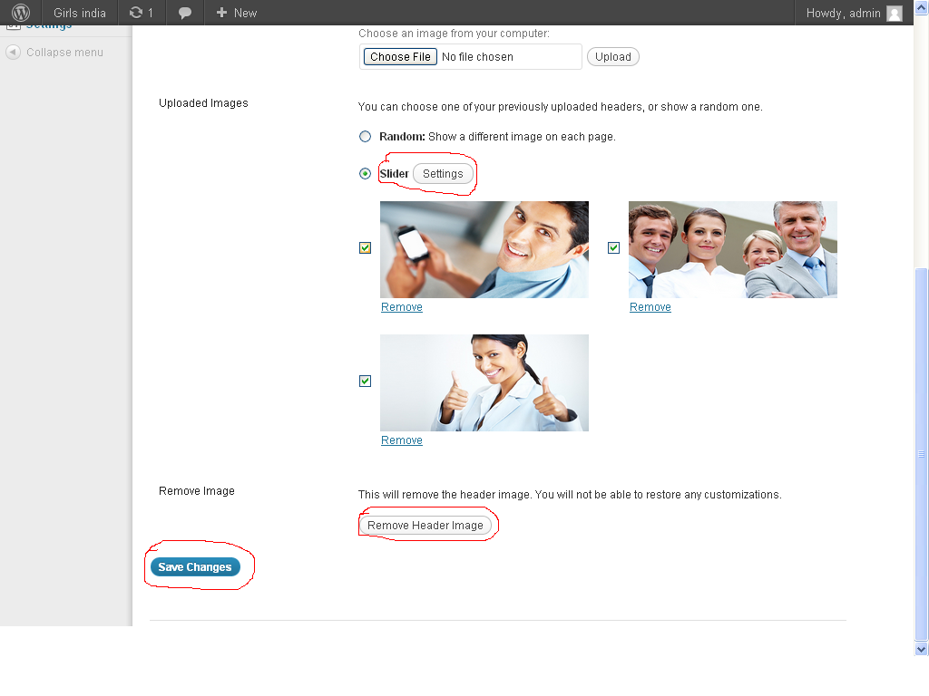
Figure 10

